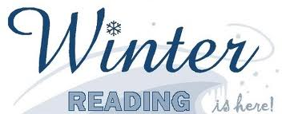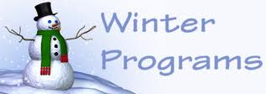

The Silver Bay Public Library
2018 winter reading program
“READ WITH A FRIEND!”
“January 16th - March 2nd, 2018

JOIN US FOR SOME FRIDAY FUN ACTIVITIES:

Fri., January 26th @ 1:00 PM SLED DOGS (stories & craft)

Fri., February 9th @ 10:30 AM Duluth Playhouse MAD SCIENCE of
MINNESOTA

Fri., February 9th @ 1:00 PM DESIGN A BOOK BAG event. Thank You for
using our library!!

Fri., February 16th @ 1:00 PM S’MORES & HOT CHOCOLATE
(Outside activity - dress appropriately)

Fri., February 23rd @ 1:00 PM WINTER CARD CREATIONS

Fri., March 2nd @ 1:00 PM DR. SEUSS BIRTHDAY PARTY

SPRING STORY TIME will be held on Wednesdays at 12:00 PM January 17th – May 9th, 2018

Sign up for the reading program and earn prizes!! After registration, small incentives (2 prizes per week for reading and one per star on activity sheet) are earned weekly. $2 Book money is earned after reading 300 and 700 minutes.

