Greetings!
Welcome to the City of Silver Bay. Enclosed you’ll find information on our historic City.
The first thing you’ll want to do if you recently purchased a home, is stop by City Hall to transfer utility services. You’ll be asked to complete a form and pay a transfer fee to get the city utility services into your name and billed to the appropriate address.
Persons or businesses wishing to locate or relocate to one of Minnesota’s most scenic areas on the North Shore of Lake Superior should get in contact with the City Administrator. The Business Park is located on U.S. Highway 61 and is roughly 110 acres with irregular property lines.
The City has designated the North Shore Journal as its official newspaper, a free publication mailed out to all residents. It can also be picked up at most local businesses. Here you will find current information on the City. Ordinance amendments, Public Hearing notices, job postings, and current events are a few things you’ll find in the paper.
The Friends of the Silver Bay Public Library publish a Silver Bay Area Organizations and Businesses Directory annually. Copies are available at the Public Library or you can find information on the city website.
7 Davis Drive, Silver Bay, MN 55614 | P: (218)226-4408 F: (218)226-4068 | www.silverbay.com
Welcomes You

During the winter months, our Street Department work tirelessly to clear the roads and sidewalks of snow. Depending on the snow amounts, they may not get to the sidewalks immediately. It is greatly appreciated if you are able to clear the snow from sidewalks near your property during such snow events. No one shall deposit snow upon the property of another, into city streets or onto sidewalks. Parking is not allowed on city streets between the hours of 11PM and 6AM or during any time that snowplowing or snow removal operations are in progress, beginning November 1 through April 30. Parking on the boulevard is not allowed any time of the year.
The police monitor un-kept yards. The nuisance ordinance is meant to make our City a safe and clean place to live. All this takes is some common courtesy and pride in one’s property.
Consider serving on a City Board or Commission. Our City Council relies on these bodies in decision making. If you are interested in serving please check the City website or contact City Hall.
The mission of the City of Silver Bay is to make Silver Bay a great place to live, work and visit by providing cost-effective government and services to improve the lives of those it serves.
Welcome to our great city!

- The residential garbage/recycling must be on the boulevard by 8AM each Wednesday, with approved garbage tags, for collection
- Approved garbage tags can be purchased at John’s Sanitary Removal or Julie’s True Value
- City ordinances and permits can be found online or at City Hall
- All dogs and cats over 6 months of age must be licensed through the City annually with proof of current rabies vaccination
- Help support the Public Library at the annual book sale held during Bay Days
- Visit the Silver Bay Liquor Store and Lounge for drink and food specials and special events, like Bean Bag tournaments and live music
- Parks & Recreation programs, activity registration information, and schedules are found on the City website
- The City’s Parks & Recreation Department offers a Senior Workshop open to anyone 55 years or older
- The Silver Bay Golf Course welcomes you to play a round of golf, shop in the Pro Shop, or have lunch at the Sandwich Grill open daily from Mother’s Day through the season’s end
- Contact the Lake County Assessor’s Office at (218) 834-8310 with questions regarding your property values
- Follow the Police Department on Facebook for the most up to date info - facebook.com/SilverBayPD/
City CONTACTS

City Hall
7 Davis Drive, Silver Bay, MN 55614
(218) 226-4408
www.silverbay.com

Police Department
7 Davis Drive, Silver Bay, MN 55614
(218) 226-4486 for Non-Emergency
911 for Emergencies
www.facebook.com/SilverBayPD

Public Library
9 Davis Drive, Silver Bay, MN 55614
(218) 226-4331
www.facebook.com/Silver-Bay-Public-Library-419027874953555

Liquor Store / Lounge
95 Outer Drive, Silver Bay, MN 55614
(218) 226-3106
www.facebook.com/silver.bay.munidipal

Arena / Parks & Recreation Department
129 Outer Drive, Silver Bay, MN 55614
(218) 226-4214
www.silverbay.com

Public Works Department
13 Shop Hill Road, Silver Bay, MN 55614
(218) 226-4552
www.silverbay.com

Public Utilities Department
101 E. Lakeview Drive, Silver Bay, MN 55614
(218) 226-3663
www.silverbay.com

Black Beach Campground
200 W. Lakeview Drive, Silver Bay, MN 55614
(218) 226-1825
www.blackbeachcampground.com

Silver Bay Marina
99 Beach Drive, Silver Bay, MN 55614
(218) 226-3121
www.silverbay-marina.com

Fire Department
87 Banks Blvd, Silver Bay, MN 55614
911 for emergencies
www.facebook.com/Silver-Bay-Fire-Department-361271164256807

PUBLIC UTILITIES
Residential water, sewer, and garbage services are non-metered and are billed on a quarterly basis and are due upon receipt. Business accounts are metered and billed monthly. You are welcome to make payments throughout the quarter. A $15 late fee will be incurred if payment is not received in full within the City Administrator’s office by 4PM on the last business day of each quarter for residential accounts and the last business day of each month for all business accounts. Any payments received after 4PM or received on the weekend will be credited on your account the next business day.
There is a drop box in front of City Hall for your convenience. Place your payment and small card stub together, in an envelope, staple or paper clip them together and drop them into the box. The box is emptied each business day.
Don’t forget to transfer utilities into your name. The City utilities stay with the property. It’s in the buyer’s best interest to coordinate with the seller to make sure they have paid their share of the bill. If the account becomes delinquent, a notice and the utility shut-off procedure will be mailed out. If the account balance is not paid by the deadline, the Public Utilities Commission will issue a utility shut-off order.
Voluntary water turn-off and turn-on requests should be submitted at least 2 days before the requested date. There is a fee to have water shut-off and a fee to have the water turned on. Once the water is turned off or on, the account will be adjusted and a revised bill will be mailed if it has not already been paid. The City does not pro-rate accounts. If the water is on for just one day, you are charged the full amount. If the water is off for the entire month, the rate is adjusted to half water and half sewer. Garbage and tax is not incurred.
7 Davis Drive, Silver Bay, MN 55614 | P: (218)226-4408 F: (218)226-4068 | www.silverbay.com
Residential garbage will be collected only with an approved tag that is attached to the bag or 30 gallon garbage can. Purchase your tags at Julie’s True Value located in the Shopping Center. The garbage service provider asks that you have your garbage and recycling on the boulevard by 8AM on Wednesday for collection.
PUBLIC WORKS
The City of Silver Bay Public Works Department is responsible for the city storm sewer system, streets, cemetery, and airport, which the runway is closed permanently. Call the department if you’d like to choose and purchase a cemetery block. The department is responsible for snow plowing, sanding, pothole patching, sidewalk replacement, city right of way maintenance, storm sewers, and boulevard tree care.
No person shall park any vehicle nor place any personal property upon any boulevard which is the area between the curb line and the property line. The City designates exchange days for residents to place unwanted items on their boulevard. Watch the local paper or call City Hall for designated exchange day dates.
No person shall park any vehicles, or combination of vehicles, including but not limited to Motor Homes, Campers and other Recreational Vehicles, that is 22 feet or more in length, or any vehicle that is more than 6 ½ feet in height or width on any street within the city limits for more than 24 consecutive hours unless authorized in writing by the Silver Bay Police Department.
The City asks that you do not rake leaves, grass, etc. into the City streets as they will collect on top of the storm sewers, plugging them, preventing proper water drainage. Property owners are responsible for maintaining boulevard grass, but prohibits any alterations to the boulevard including trees. The City Code prohibits trimming of boulevard trees. Please contact the City Hall or the Street Department if you feel your boulevard tree needs trimming.
Periodically a city street light may go out, work intermittently or “blink” quite continuously. Should this happen, please call City Hall or Street Department to explain the problem and location of the street light. We will, in turn notify the power company to repair the light.
PERMITS
All permits can be downloaded from the City website or obtained at City Hall. Some of the most common permits are Land Use, Building, Plumbing, Driveway Approach, Recreational Fire or Open Burning, Dance, Home Use Occupation, and Conditional Use.
Permits are required for items such as: new construction, alterations / remodeling, sheds, fences, decks, garages, additions, repaving of driveway approach, demolition or moving of any building.
Permits may not be required for items such as: residing (unless you alter the sheathing), repaving (unless you repave driveway approach), window replacement (unless you change the size or add windows), shingling (unless you change physical aspects), repairs, maintenance or minor alterations that do not change the physical dimensions or shape of any building or structure on land.
For anyone wishing to operate a home-based business, which generates additional traffic within the neighborhood, must apply for a Home Use Occupation permit. There are some occupations that do not require a permit such as Home Retail Parties (Tupperware, Thirty One, Pampered Chef, etc.), Daycares, and Telemarketing. All Home Use Occupation permits require a public hearing and must be renewed every three (3) years.
The purpose of the permits is to insure the city ordinances are followed and insures changes to properties follow the appropriate building codes and regulations.
Reminder – Call before you dig! Request locates by calling Gopher State One Call at 811, (651) 454-0002, or 800-252-1166.
PARKS & RECREATION
The Silver Bay Parks and Recreation Department maintains a multitude of parks and facilities in the Silver Bay area, such as Bayside Park and Silver Bay Marina, Black Beach Park and Campground, Baseball and Softball Fields, a Horseshoe Court, a Skate Park, Tennis Courts, Mary Mac and Rec Building Playgrounds, a Senior Citizens Workshop, an Outdoor Rink, a Recreation Building, and the Rukavina Arena. Visit the Parks and Recreation webpages to view current program registration information and schedules.
The Recreation Department runs a 6-7 week summer recreation program. Activities include baseball, softball, pickle ball, tennis, dryland hockey, volleyball camp, golf, and Prairie Fire Theatre. The Rukavina Arena hosts many hockey games, tournaments and leagues, and camps. Check their website for more information on games, leagues, camps, programs and schedules.
7 Davis Drive, Silver Bay, MN 55614 | P: (218)226-4408 F: (218)226-4068 | www.silverbay.com
PUBLIC LIBRARY
The library strives to provide the best library service for its customers. As a member of the Arrowhead Library System, resources are available from the 27 other libraries in the system. Permanent residents of the Arrowhead may apply, free of charge, for a library card. The card may be used throughout the Arrowhead Library System of Minnesota. Non-residents and temporary borrowers may pay a $10.00 fee for 3 months access to physical items with no digital access. Computers and internet access are available for usage by the public. Using the internet in the library constitutes acceptance of the Silver Bay Public Library Acceptable Use Policy.
The Book Club meets the first Monday of every month (unless it’s a holiday) at 6PM at the Library. Call the library for the current listing. Stop by the Library to join the Book Club.
Dolly Parton’s Imagination Library mails a high quality, age-appropriate book to all registered children from birth to age five, addressed to them monthly, at no cost to the child’s family. Books are 100% free to enrolled children because their Local Champion, Friends of the Silver Bay Public Library, has secured funds to cover the cost of the books and the shipping fees. Visit the library webpage for more information.
PROSPECTIVE BUSINESS
Silver Bay’s Business Park is accessed by highway 61 and is one of the few parcels that is properly zoned for development and served by our
municipal water and sewer services. Staff will initiate City review, upon receipt of the originally signed and
completed application for Land Development, along with a non-refundable application fee, and all required exhibits. Applications go through a 3rd Party confidential financial review. The City will receive recommendations from the financial institution regarding the viability of the business.
The Mary MacDonald Center is a 68,000 square foot facility located in Silver Bay zoned as a Planned Unit Development. This zoning allows for multiple uses and makes the center the perfect location for a business incubator. Individual units are available with sizes starting at 600 square feet. Both wired and wireless high-speed internet connections are available with existing businesses located in the center. Full utilities are included in most leases, along with ample weekday parking and managerial services.
Contact the City Administrator for information relating to starting your business in the City of Silver Bay.

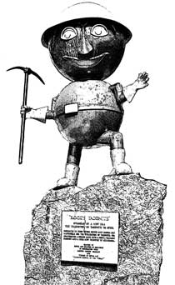

City of Silver Bay Walking Map

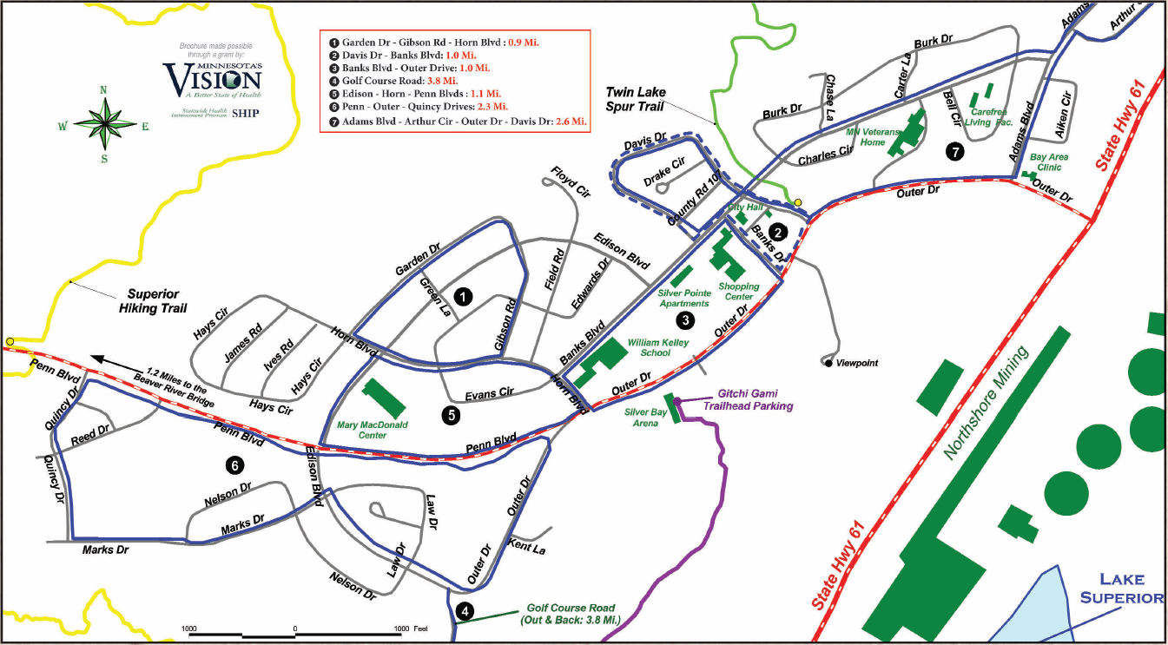

2
1
Garden Dr - Gibson Rd - Horn Blvd: 0.9 Mi.
Davis Dr – Banks Blvd: 1.0 Mi.
Banks Blvd – Outer Drive: 1.0 Mi.
Golf Course Rd: 3.8 Mi.
Edison Blvd – Horn Blvd – Penn Blvd: 1.1 Mi.
Penn Blvd – Outer Dr – Quincy Dr: 2.3 Mi.
Adams Blvd – Arthur Cir – Outer Dr – Davis Dr: 2.6 Mi.
4
3
7
6
5
SILVER BAY AREA TRAIL MAP

