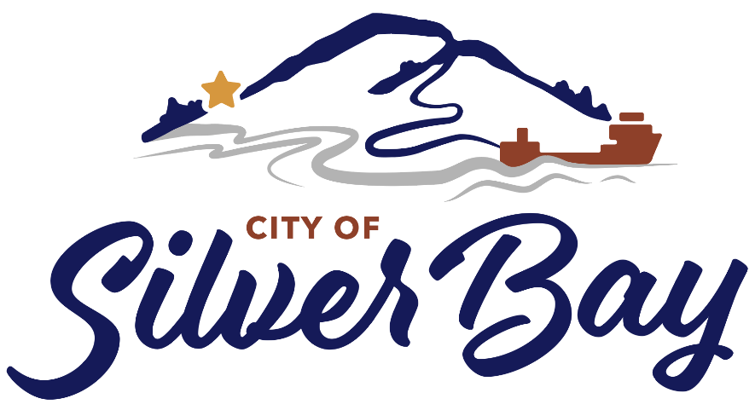
GUIDELINES FOR THE
CITY OF SILVER BAY COVID-19 TACONITE COMMUNITY RELIEF LOAN PROGRAM
PURPOSE:
The City Council of the City of Silver Bay, through its Economic Development Authority, and in cooperation with Iron Range Resources and Rehabilitation Board (IRRRB), has developed a loan fund, known as the COVID-19 Taconite Community Relief Loan Program, for the purpose of providing financing for eligible businesses in Silver Bay who have been impacted by the COVID-19 Pandemic. Capitalization of this program came from a 4:1 match basis, whereas the Iron Range Resources provided $4 for every $1 of local match.
The funds for this program will come from a $50,000 grant from IRRRB with $12,500 in matching dollars from the City of Silver Bay’s EDA Revolving Loan Fund (271) for a total loan pool of $62,500 to be loaned to Silver Bay Businesses. Repayment of the loan funds will be retained by the City of Silver Bay for future Economic Development needs. Once these funds have been expensed, no further funding from this program will be available.
The principal objective of the program is to offer assistance with working capital, delayed business expansion, delayed capital asset investment, or other business needs that have been delayed due to the impacts of COVID-19. Secondary objectives are to stimulate investment, expand the tax base, retain businesses, and job retention or expansion in Silver Bay.
LOAN AMOUNTS:
The minimum loan amount is $2,500 and the maximum loan exposure from this loan fund shall be approved by the City of Silver Bay, but cannot exceed $62,500. The amount to be loaned is at the sole discretion of the City and will be dependent upon the number of applications and the availability of funds. The City must expense all of the funds from this program prior to June 30, 2021.
GEOGRAPHIC AREA OF PROGRAM:
The COVID-19 Taconite Community Relief Loan Program exists for businesses located in the City of Silver Bay with priority given to small businesses.
ELIGIBLE BUSINESSES:
Funds used through the COVID-19 Taconite Community Relief Loan Program must be for a business located in an existing building in the City limits of Silver Bay, have been in operation for at least one year, and operating on March 1, 2020. Eligible applicants include, but are not limited to, those businesses which are engaged in:
- Retail Sales
- Lodging Facility
- Auto Repair
- Information Industries
- Restaurants
- Service Sector Businesses
- Financial Institutions
- Tourism
FINANCING POLICIES:
- ALLOWABLE USE OF PROCEEDS

Use of the COVID-19 Taconite Community Relief Loan Program shall include working capital, business expansion, capital asset improvements, or other business improvements that were delayed due to the pandemic. Improvements should be designed to meet the letter of the law to be in accordance with the American’s with Disabilities Act (A.D.A.) Federal regulations.

- TERM OF LOANS

The length of any loan made by the COVID-19 Taconite Community Relief Loan Program will be based upon the amount of the loan. The term of any loan shall not exceed the following and will be repaid on a monthly basis:
Loans between $2,500 and $10,000 will be a three (3) year term;
Loans over $10,000 will be a Five (5) year term
- LOAN FORGIVENESS

Twenty-five percent (25%) of the loan shall be forgiven if the business completes the following:
  - Remains in operation within the City of Silver Bay for the entire term of the loan – 3 years for loans under $10,000 or 5 years for loans of $10,000 or more up to the maximum amount allowable, not to exceed $62,500.
  - Retains employees at the same level or more, based upon the date of the application through the entire term of the loan.

- INTEREST RATE OF LOANS

Interest Rates on all loans will be at 1% interest and fixed throughout the term of the loan.

- FEES AND CHARGES
At the option of the City of Silver Bay, through its Economic Development Authority, all or part of the legal costs incurred by the COVID-19 Taconite Community Relief Loan Program in the closing of the Borrower’s Loan may be passed on to the Borrower.

Any Authorized lending institution shall receive, for originating and servicing such loan, a fee to be paid by applicant.

- OTHER FINANCING POLICIES
- Any loan made by the City of Silver Bay shall be adequately secured to the satisfaction of the City of Silver Bay.
- Any loan made by the City of Silver Bay shall be personally guaranteed by the principal owners of the borrower to the satisfaction of the City of Silver Bay.
- All loans shall be subject to whatever agreements and documents are reasonably necessary to protect the interests of the City and to ensure that the purpose and intent of this program are met.
- The recipient of such loan or other financial assistance is credit worthy and has the ability to perform its obligations under any agreements to be entered into with the City.
- Benefits will be realized by the citizens of the City in the form of a more attractive and accessible building, jobs, retention of business and/or increased tax base.
- Any loan agreement between the City of Silver Bay and the Borrower shall require:
  - That the Borrower submits to the City of Silver Bay documentation for how the funds were used, including receipts.
  - The business shall comply and obtain proper permits with the local zoning ordinances prior to any improvements, if applicable.
  - The business shall have 180 days to expense funds, or obtain approval by the City for extension.
  - The business shall supply before and after photographs of any improvements.
THE CITY NEED NOT MAKE A LOAN OR PROVIDE OTHER FINANCIAL ASSISTANCE TO A BUSINESS THAT MEETS ALL OF THE REQUIREMENTS OF THESE GUIDELINES UNLESS THE CITY IN ITS SOLE DISCRETION DETERMINES THAT IT IS IN THE BEST INTERESTS OF THE CITY TO MAKE SUCH LOAN OR PROVIDE SUCH OTHER FINANCIAL ASSISTANCE.
APPLICATION PROCESS:
- FULL-APPLICATION
The City of Silver Bay Economic Development Authority will discuss full details of application preparation and guidelines with the applicant. The applicant will fully complete all of the required documentation. A third-party financial review by the Northshore Federal Credit Union, or another bank of the City’s choosing, will be conducted based upon the information submitted by the applicant. The Credit Union or Bank used will make a recommendation for financing to the City. The City of Silver Bay Economic Development Authority will review the application and recommendation by the Credit Union or Bank and make a decision on the application. Should the EDA decide to approve the application; the application will be forwarded for City Council Approval.
- LOAN CLOSING PROCESS
The City of Silver Bay will prepare all the proper closing documents, which shall include the Promissory Note, the Security Agreement, UCC-1 Financing Statement, a Loan Amortization Schedule, and any other documents required for closing. The closing documents will be executed by all parties. Copies of executed closing documents will be filed with the City of Silver Bay. Funds will be disbursed to the business.
NOTE: AT ANY POINT IN THE REVIEW PROCESS, THE APPLICATION MAY BE DENIED OR SENT BACK FOR FURTHER INFORMATION.

