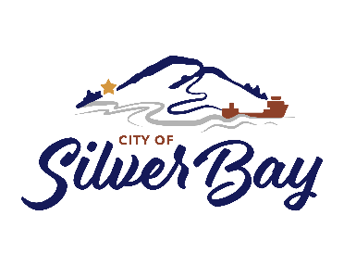
PUBLIC NOTICE
The City Council of Silver Bay will be holding a Public Hearing to discuss the proposed City Code Adoption of Section 1239 relating to Short Term Rentals, City Code Amendment for Section 1210.10 FR (Forest Reserve) and 1210.13 BP (Bayview Park) Zones relating to Short Term Rentals, and the City Zoning Map Amendment. The Public Hearing will be held on Monday, May 15, 2023 at 7:00pm in the City Council Chambers of City Hall, located at 7 Davis Drive, Silver Bay, MN 55614. Anyone wishing to make comments may do so by attending the Public Hearing, or by submitting comments in writing by 4:00pm on Monday, May 15, 2023. Written comments can be sent via email to lanaf@silverbay.com or by mail to the City of Silver Bay at the address noted above. A copy of the documents are available for review at City Hall or on the City website at www.silverbay.com. Should anyone have questions regarding the public hearing please contact Lana Fralich, City Administrator, at 218-226-4408.

